

Chinese New Year
Thursday 26th February 2026


Cantonese style sweet & sour chicken with long grain rice, broccoli
and soy sauce!

Vegetable chow Mein
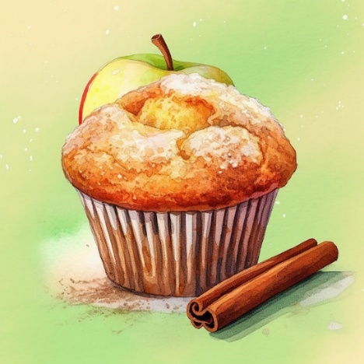
Cinnamon muffin
for dessert!

